**NFT ASSIGNMENT-1 CODE**

import pandas as pd

import numpy as np

from sklearn.model_selection import train_test_split

from sklearn.preprocessing import LabelEncoder, StandardScaler

from sklearn.metrics import accuracy_score, classification_report, confusion_matrix

# Load the dataset

df = pd.read_csv("Loan Prediction Dataset.csv")

# Data preprocessing

# Handle missing values

df['LoanAmount'] = df['LoanAmount'].fillna(df['LoanAmount'].mean())

df['Loan_Amount_Term'] = df['Loan_Amount_Term'].fillna(df['Loan_Amount_Term'].mean())

df['Credit_History'] = df['Credit_History'].fillna(df['Credit_History'].mean())

df['Gender'] = df['Gender'].fillna(df['Gender'].mode()[0])

df['Married'] = df['Married'].fillna(df['Married'].mode()[0])

df['Dependents'] = df['Dependents'].fillna(df['Dependents'].mode()[0])

df['Self_Employed'] = df['Self_Employed'].fillna(df['Self_Employed'].mode()[0])

# Log-transform numerical features

df['ApplicantIncome'] = np.log(df['ApplicantIncome'])

df['CoapplicantIncome'] = np.log(df['CoapplicantIncome'] + 1)  # Adding 1 to avoid log(0)

df['LoanAmount'] = np.log(df['LoanAmount'])

df['Loan_Amount_Term'] = np.log(df['Loan_Amount_Term'] + 1)  # Adding 1 to avoid log(0)

# Encode categorical variables

encoder = LabelEncoder()

categorical_columns = ['Gender', 'Married', 'Dependents', 'Education', 'Self_Employed', 'Property_Area', 'Loan_Status']

for col in categorical_columns:

    df[col] = encoder.fit_transform(df[col])

# Data Split

X = df.drop(columns=['Loan_Status', 'Loan_ID'], axis=1)

y = df['Loan_Status']

X_train, X_test, y_train, y_test = train_test_split(X, y, test_size=0.2, random_state=42)

# Standardize the features

scaler = StandardScaler()

X_train = scaler.fit_transform(X_train)

X_test = scaler.transform(X_test)

# Define the Multi-Layer Perceptron (MLP) architecture

class MLP:

    def __init__(self, input_size):

        self.input_size = input_size

        self.hidden_size = 128

        self.output_size = 1

        self.weights_input_hidden = np.random.randn(self.input_size, self.hidden_size)

        self.bias_hidden = np.zeros((1, self.hidden_size))

        self.weights_hidden_output = np.random.randn(self.hidden_size, self.output_size)

        self.bias_output = np.zeros((1, self.output_size))

    def sigmoid(self, x):

        return 1 / (1 + np.exp(-x))

    def sigmoid_derivative(self, x):

        return x * (1 - x)

    def forward(self, X):

        self.hidden_input = np.dot(X, self.weights_input_hidden) + self.bias_hidden

        self.hidden_output = self.sigmoid(self.hidden_input)

        self.output = self.sigmoid(np.dot(self.hidden_output, self.weights_hidden_output) + self.bias_output)

        return self.output

    def backward(self, X, y, output, learning_rate):

        self.output_error = y - output

        self.output_delta = self.output_error * self.sigmoid_derivative(output)

        self.hidden_layer_error = self.output_delta.dot(self.weights_hidden_output.T)

        self.hidden_layer_delta = self.hidden_layer_error * self.sigmoid_derivative(self.hidden_output)

        self.weights_hidden_output += self.hidden_output.T.dot(self.output_delta) * learning_rate

        self.weights_input_hidden += X.T.dot(self.hidden_layer_delta) * learning_rate

        self.bias_output += np.sum(self.output_delta, axis=0, keepdims=True) * learning_rate

        self.bias_hidden += np.sum(self.hidden_layer_delta, axis=0) * learning_rate

    def train(self, X, y, epochs, learning_rate):

        for _ in range(epochs):

            output = self.forward(X)

            self.backward(X, y.values.reshape(-1, 1), output, learning_rate)

# Initialize and train the MLP

input_size = X_train.shape[1]

mlp = MLP(input_size)

mlp.train(X_train, y_train, epochs=50, learning_rate=0.01)

# Predict on test data

y_pred = (mlp.forward(X_test) > 0.5).astype(int)

# Calculate and print accuracy

accuracy = accuracy_score(y_test, y_pred)

print("Accuracy:", accuracy)

# Print classification report and confusion matrix

print(classification_report(y_test, y_pred, zero_division=0))

print("Confusion Matrix:")

print(confusion_matrix(y_test, y_pred))

Accuracy: 0.7642276422764228

precision recall f1-score support

0 0.79 0.44 0.57 43

1 0.76 0.94 0.84 80

accuracy 0.76 123

macro avg 0.77 0.69 0.70 123

weighted avg 0.77 0.76 0.74 123

Confusion Matrix:

[[19 24]

[ 5 75]]

import matplotlib.pyplot as plt

import seaborn as sns

from sklearn.metrics import confusion_matrix, roc_curve, roc_auc_score, auc

# Confusion Matrix

cm = confusion_matrix(y_test, y_pred)

plt.figure(figsize=(8, 6))

sns.heatmap(cm, annot=True, fmt="d", cmap="Blues", cbar=False)

plt.xlabel('Predicted')

plt.ylabel('True')

plt.title('Confusion Matrix')

plt.show()

# ROC Curve and AUC

fpr, tpr, thresholds = roc_curve(y_test, y_pred)

roc_auc = auc(fpr, tpr)

plt.figure(figsize=(8, 6))

plt.plot(fpr, tpr, color='darkorange', lw=2, label=f'ROC curve (AUC = {roc_auc:.2f})')

plt.plot([0, 1], [0, 1], color='navy', lw=2, linestyle='--')

plt.xlim([0.0, 1.0])

plt.ylim([0.0, 1.05])

plt.xlabel('False Positive Rate')

plt.ylabel('True Positive Rate')

plt.title('Receiver Operating Characteristic (ROC) Curve')

plt.legend(loc='lower right')

plt.show()

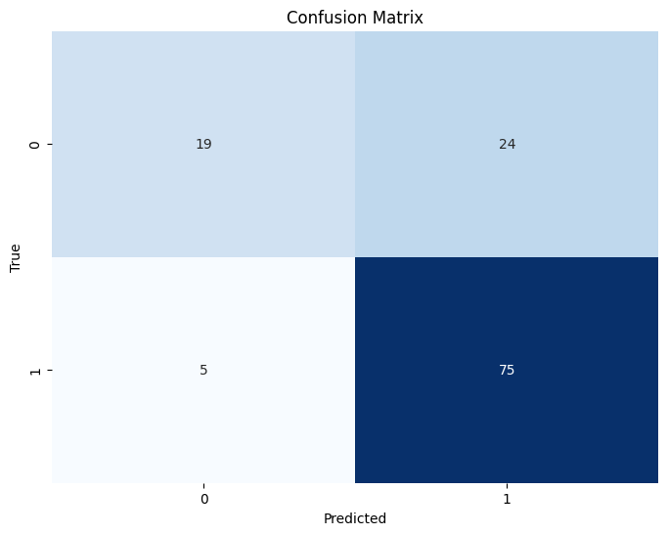

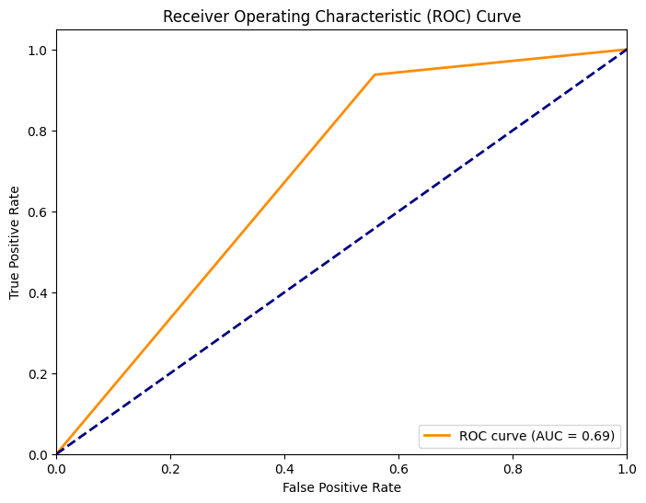

**DONE BY:**

**BT21CSE100-Katnapalli Rishitha**

**BT21CSE106-Anandapu Srihitha**